Echoview template designed for mini signature 100 Nortek echosounder attached to a Slocum G3 glider for use by US Antarctic Marine Living Resources (AMLR) program.

February 22, 2023

This template was designed using Echoview 13.

Considerations: Due to so many frequencies, the pings do not match up on all the frequencies.

**Filesets:** This uses four different filesets. 

**Acoustics** - The acoustic data (*.ad2cp) is from the echosounder. The wideband echosounder currently outputs discrete frequencies of 70, 73.8, 82.3, 90.9, 99.4, 107.9 and 120 kHz. The acoustic data has embedded heading, pitch and roll data but the template is currently set up to use glider pitch and roll data, and not echosounder pitch data.

**GPS** - A GPS file must be created from the Slocum glider data (*.gps.csv). The file has date, time, Latitude, and Longitude (GPS_date, GPS_time, Latitude, and Longitude).

**Pitch** - The pitch data file (*.pitch.csv) has three columns: Pitch_date, Pitch_time, Pitch_angle.

**Roll –** This is currently not used but can be integrated into the template. The file (*.roll.csv) will have three columns: Roll_date, Roll_time, Roll_angle.

The GPS, Pitch, Roll, and DEPTH files are currently created using the Matlab code found on Github (<https://github.com/acossio/glider_processing_code>)

**Calibration**



**Calibration** **file**: Like all acoustic data, an Echoview calibration file is necessary (*.ecs). If you don’t have one, you can open the raw data first, then select the “New” button. This will read in the calibration variables. Once you have a calibration file, you can edit the file with survey temperature and sound speed.

**Dataflow**

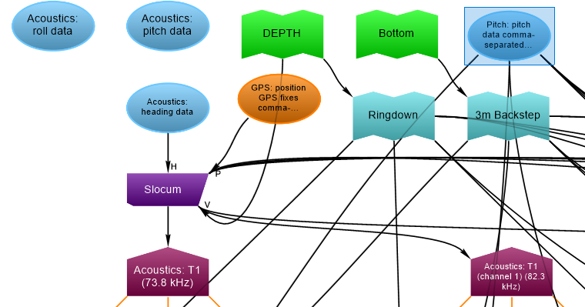

**Platform**: In the Dataflow view, all of the variables are able to be viewed and interacted with. First is the Platform which is called “Slocum.” This reads in the GPS file set.

**Depth -** It also requires a DEPTH line to be imported into Echoview as well to have the gliders depth associated with the data. The DEPTH line data (*.evl) will need date, time, depth, and line status (3 is for good data). To import the data, select File -> Import… then select the file and select “Extend/overwrite an existing line” DEPTH, then press the Import button.

**Ringdown** – A three meter offset was created from the DEPTH line to take into account the ringdown of the echosounder.

**Bottom** – A user editable line to trace the ocean bottom.

**3m Backstep** – An automatic line that creates a 3 m backstep from the Bottom line. Anything data below this line will be excluded.

**Analysis**

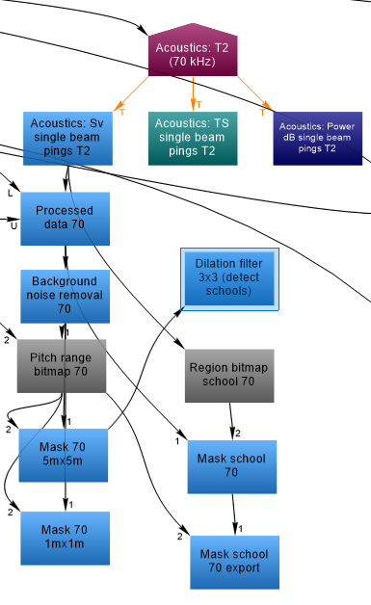

Each frequency follows the same analysis. First, raw Sv data is used for the analysis

**Processed data** is applied. This determines data as only good if they fall within the Ringdown line and the 3m Backstep line if there is one. Also, any regions marked as Bad Data will also be removed from analysis.

**Background noise removal** then removes background noise. Adjust as needed to remove the “rainbow effect.”

**Pitch range bitmap** filter is applied. It can be used to only analyze dive data or climb data. It is currently set at -30 and -10 for dives only.

**Mask** **5mx5m** - uses a mask that makes the data that the Pitch range bitmap throws out not part of the analysis. This mask is set to Export – Analysis by cells – Integration in 5m by 5m bins.

**Mask 1mx1m** – is the same as Mask 5mx5m except in 1m by 1m bins.

**School detection and export**

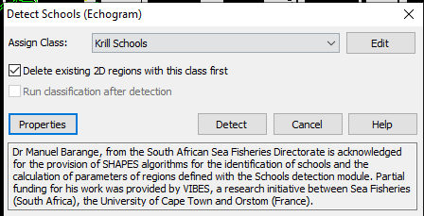

**Dilation filter 3x3 (detect schools)** – School detection is only done off of the 70 kHz. Open this variable, then go to Echogram – Detect schools. Make sure “Delete existing 2D regions with this class first is checked. Then select “Detect.” Once detection is done, you can close this and proceed. The school properties setting are currently set below.

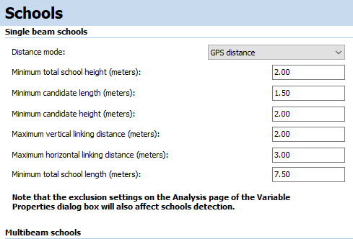

**Region bitmap school** – This variable selects the schools that were detected using the Dilation filter 3x3 (detect schools) as good data and the rest of the data as empty water.

**Mask school** – This mask applies the Region bitmap school to the Background noise removal variable.

**Mask school export** – This mask uses the Mask school and applies the Pitch range bitmap. Export the schools by selecting Echogram – Export – Analysis by regions – Integration – check box for Krill Schools – Export …

**Exports –**

The **exports by cell** csv files have standard information for start, middle, and end pings for that bin (Date, Time, Lat, Lon). Frequency, Standard_deviation, Sv_mean, Sv_max, Height_mean, and Depth_mean are also output. Program_version and EV_filename are added to recreate the data more easily.

In order to have “Echometrics” (Urmy, et al 2012) available, the following export variables are also output: ABC, Area_Backscatter_Strength, Center_of_mass, Inertia, Proportion_occupied, Equivalent_area, Aggregation_index

For school output the following outputs are exported: Uncorrected_length, Uncorrected_thickness, Uncorrected_perimeter, Uncorrected_area, Corrected_length, Corrected_thickness, Corrected_perimeter, Corrected_area, Horizontal_roughness_coefficient, Vertical_roughness_coefficient.

|  |  |  |  |  |  |  |  |  |  |  |  |  |  |  |  |  |  |  |  |  |  |  |  |  |
| --- | --- | --- | --- | --- | --- | --- | --- | --- | --- | --- | --- | --- | --- | --- | --- | --- | --- | --- | --- | --- | --- | --- | --- | --- |
|  | ----------- |  |  |  |  |  |  |  |  |  |  |  |  |  |  |  |  |  |  |  |  |  |  |  |

**Change log:**

4/25/23 – Deleted Pitch Range bitmaps and replaced them with Region bitmaps, to allow for “Dive” and “Climb” regions that are based on glider profile data instead of pitch angles.

Added a 10m virtual line to remove the first 10m of the dive due to uncertainty of krill or air bubbles. This will have to be investigated further. Added Mask FREQ 10m from Processed data FREQ to Background noise removal FREQ

Changed “Krill schools” to “Krill Schools 70” and added “Krill Schools 120”.

Added Dilation filter 3x3 120 (detect schools) so we can have schools detected using both 70 and 120 kHz.